VANDERBILT STUDENT VOLUNTEERS FOR SCIENCE
http://studentorgs.vanderbilt.edu/vsvs

FLUORESCENCE, PHOSPHORESCENCE, CHEMILUMINESCENCE

OBJECTIVE: To study fluorescence, phosphorescence, and chemiluminescence through demonstrations and hands-on activities.
Fits Metro Davidson County schools Science Academic Standards for Grades 6.
Text reference: Chapters 15, 17.

LESSON OUTLINE
I. Electromagnetic Radiation, p. 2
Give each student one of the handouts and one of the instruction sheets. Briefly explain electromagnetic radiation and point out the different types - X rays, UV, IR, and radio waves. Mention that the difference in energy is because of their differences in wavelength or frequency. They all travel at 300 million meters per second (speed of light).
II. Visible Light Can Be Separated Into Different Colors, p. 3
A. Diffraction Gratings - Students hold up what looks like a blank slide and look at room lights or outside light through a window and see separation of white light into several rainbows. The slide actually contains about 1500 lines per centimeter. Each space between two grooves acts as a slit through which light can pass. When illuminated with white light, the diffraction grating has the same effect as a prism.
B. CD - Students hold the CD in a way that produces “rainbow” patterns. CD’s have many parallel grooves so the CD acts like a diffraction grating.
III. Laser Light is One Wavelength of Color, p. 4
Be careful not to point the laser pointer at anyone. Don’t let students handle the laser pointer. Use the laser pointer and the diffraction grating to show that the red laser produces only one color when the laser light shines through a diffraction grating.
IV. Different Types of Emitted Light, p. 5
Go over the flow diagram on page 6 and discuss the two general classifications - incandescence and luminescence. The activities in the lesson relate to various forms of luminescence - chemiluminescence, fluorescence, and phosphorescence. Triboluminescence and bioluminescence are also mentioned.
V. Activities, p. 7
A. Tonic Water Fluorescence - Shine a black light on tonic water - fluoresces (appears blue)
B. Narra Wood Water Extract Fluorescence – Shine a black light on the jar labeled “narra wood extract” – fluoresces. Show them the small piece of narra wood and explain what narra wood is and its historical significance.
C. Bluing agents - Example of Fluorescence
Shine the black light on white paper, white T-shirts, white tennis shoes - fluoresces. Students dip a Q-tip in the bottle of bluing agent and write their first name on a paper towel. When the black light is shown on the paper towel, their name fluoresces.
D. UV Detecting Bracelet - Example of Phosphorescence
Students make a bracelet that they get to keep. The beads will detect UV radiation.
Shine the black light on their bracelet, and then turn it off. The UV beads will glow after the black light is removed. You may have to turn off the room lights for them to see the beads glow. The braid used for the bracelet also glows in the dark, even after being exposed to visible light.
VI. Review, p. 9
Go over the electromagnetic radiation diagram and the flow diagram of different types of emitted light. Review the terms to see if students understand them.
SAFETY PRECAUTION: Do not look directly at the black light; its ultraviolet light output can be damaging to eyes. Students should not be allowed to hold the black lights and should be told not to look directly at the black light.

Materials
2 Black Lights
1 demo bag containing
1 red laser pointer
1 diffraction grating
1 bag containing
32 small bags with 1 Q tip, 1 CD, 1 diffraction grating
32 1-oz cups, each with 10 UV beads of assorted colors
32 pieces of braid for stringing beads - each one is tied off on one end with one UV bead
1 Bottle of tonic water
1 water extract of narra wood
1 piece of narra wood
1 Roll of white paper towels
1 Lightstick
16 Bottles of Bluing (UltraClorox-2)
1 piece of copy paper
32 handouts - Electromagnetic Spectrum and Emitted Light Flow Diagram
33 Instruction Sheets

One VSVS team member should write the following vocabulary words on the board while the others are giving the students the handouts:
electromagnetic radiation incandescence
spectrum luminescence
visible light chemiluminescence
ultraviolet light laser light
diffraction grating refraction

I. Electromagnetic Radiation
Materials: 32 handouts

BACKGROUND INFORMATION – Electromagnetic radiation is difficult to explain. Avoid detailed explanations of “electromagnetic” if possible. A definition is given here just in case you need it. Electromagnetic waves are produced by the motion of electrically charged particles. The rest of the background information is more appropriate for your discussion with the class.

Much of the energy we receive on Earth comes from the sun. Energy travels in waves. Some waves, like light, are visible; other waves are invisible. Examples of invisible waves are ultraviolet (UV), infrared (IR), X rays, and radio waves. Both the visible and invisible forms are called electromagnetic radiation. Radiation is the process of sending out energy waves. A light bulb radiates light. A radio station radiates radio waves. The difference in energy of the different forms of electromagnetic radiation is because of their differences in wavelength or frequency. The speed of all electromagnetic radiation is the same - 300 million meters per second in a vacuum. Since visible light is the most familiar form, this speed is usually referred to as the speed of light.

• Give each student one of the handouts that include the electromagnetic spectrum and the flow diagram on emitted light. Also give each student one of the instruction sheets.

• Discuss briefly (not more than 3 minutes) the different parts of the electromagnetic spectrum and some of the vocabulary words using the Figures below. Spectrum means bands. The electromagnetic spectrum is made up of bands of different energy of electromagnetic radiation.

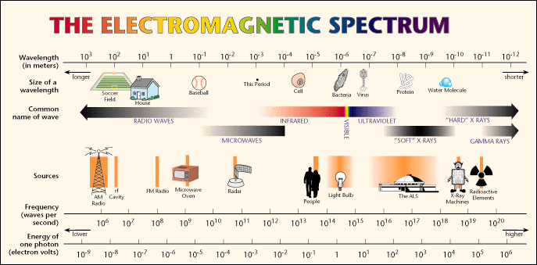
Source: http://www.lbl.gov/MicroWorlds/ALSTool/EMSpec/EMSpec2.html

White light contains all of the colors in the visible portion of the electromagnetic spectrum. The visible portion is only a small part of the entire spectrum.

R O Y G B I V
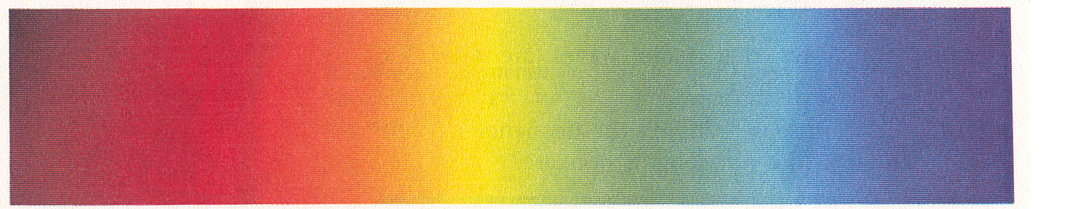

Mention that ultraviolet radiation (UV), which we can't see, is higher energy radiation next to the violet end of the visible spectrum. The black lights used in today's experiment emit ultraviolet radiation. Since UV radiation is higher energy than visible light, it can damage the eyes if viewed directly. At this point you could also mention that ultraviolet radiation from the sun is the primary cause of sunburn, and the concern about the depletion of the ozone layer in the upper stratosphere is because of its action to remove most of the ultraviolet radiation from sunlight as it passes through the layer. If the ozone layer is depleted, more ultraviolet radiation will pass through to the earth and result in higher rates of skin cancer as well as damage to marine and plant life.

II. VISIBLE LIGHT CAN BE SEPARATED INTO DIFFERENT COLORS

• Ask students to look at the visible light spectrum and identify colors that make up visible light.

Visible light is made up of all the colors that the eye can detect. The range of colors, when mixed, looks white to the eye. The three primary colors of light (additive primary colors) are red, green, and blue. When white light passes from one medium (like air) to another (like water), it is refracted. Actually, each color is refracted at a different rate - red is bent the least, while violet is bent the most. When the colors are bent and spread out they form the color spectrum. You can remember the order of the colors by naming the spectrum Roy G. Biv for red, orange, yellow, green, blue, indigo, and violet. (Some students will already know this.)

• Ask students where they have seen light broken into its different colors - answers may include a rainbow, a garden sprinkler, light shining through a prism, or on an oil film.

Over 300 years ago, Sir Isaac Newton took a glass prism into a darkened room. He focused a beam of light on the prism, and watched in fascination as the white light pouring through his window changed into a rainbow of brilliant colors. When he put another prism in front of the rainbow, the brilliant color turned once again into white light. Newton discovered that light consists of different colors.

A. DIFFRACTION GRATINGS
Materials
32 small bags with 1 Q tip, 1 CD, 1 diffraction grating

A VSVS volunteer should demonstrate the proper use of a diffraction grating slide.
Give each student a bag that contains 1 diffraction grating slide, 1 CD, and 1 Q-tip

• Hold the slide by the cardboard only.
• Do not touch the clear film in the cardboard holder.
• Hold the diffraction grating close to (but not touching) the eye and look at any lights or windows in the room.
• Several rainbows should appear.

Tell students to remain seated and simply turn around in their seats to look at the lights and
windows as they look through the diffraction grating to see the display of rainbows.

CAUTION: DO NOT LOOK DIRECTLY AT THE SUN THROUGH A DIFFRACTION GRATING
EXPLANATION: Diffraction grating slides consist of many equally spaced parallel grooves --typically about 1500 lines per centimeter. Each space between two grooves acts as a slit through which light can pass. The light bends around the edges of the grooves. When illuminated with white light, the diffraction grating has the same effect as a prism in that it separates white light into a spectrum of colors. However, the order of the colors is opposite from that seen in a spectrum made by a prism.

B. CD

• Tell the students to pick up the CD and notice the “rainbow” pattern from the room lights.

EXPLANATION: CD’s have many parallel grooves so the CD acts as a diffraction grating. The different colors in white light are bent at different rates, so a full spectrum of color can be seen when light is shone onto a CD.

III. LASER LIGHT IS ONE WAVELENGTH OF COLOR
Materials
1 demo bag containing
1 red laser pointer
1 diffraction grating

• Tell students that while white light contains all the colors, laser light is only one color
(wavelength) from the spectrum.

Safety Note: Be very careful with the laser pointer. Never aim it at anyone. When turning it on, always have it pointed away from your eyes and from other persons. DO NOT let students handle the laser pointer. Eye damage can occur with direct eye exposure to the laser beam. (It is illegal for Metro students to have laser pointers at school!)

• Turn off the lights.
• Standing several feet from the wall, shine the red laser light on the wall to show that this laser uses the red band of light. .

EXPLANATION: The term "laser is an acronym for Light Amplification by Stimulated Emission of Radiation (l.a.s.e.r). Lasers emit a single wavelength of light. The wavelength of light emitted by the red laser pointer is 670 nanometers. Visible light consists of red, orange, yellow, green, blue, indigo, and violet and ranges in wavelength from 400 to 700 nm. A nanometer is 1.00 x 10^{–9} meters.

LASERS AND DIFFRACTION GRATINGS - DEMONSTRATION
• Tell students that you will shine the red laser light through a diffraction grating to see what happens.
• Standing several feet from the wall, hold the laser light close to the diffraction grating slide.
• Shine the red laser light through the diffraction grating to show three red points of light on the wall. The red dots will be in a horizontal, vertical, or diagonal line depending on the way you hold the diffraction grating slide. Rotate the slide to see the dots change position.
• Explain to students that the dots are shining through the spots on the diffraction grating where the red light would be coming through in the visible (“rainbow”) spectrum. Since laser light contains only one color; only one color can shine through the diffraction grating.
IV. DIFFERENT TYPES OF EMITTED VISIBLE LIGHT - Have students look at the
flow diagram in sheet protector.
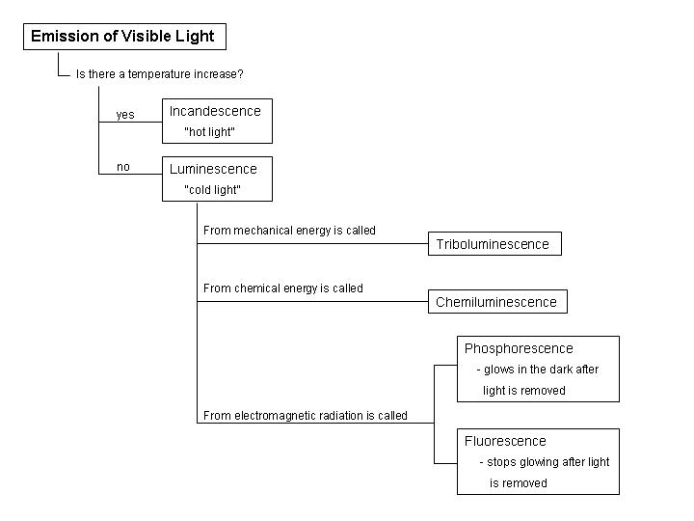

There are two general classifications of visible light emitted by matter.
A. Incandescence, known as hot light, refers to light that is emitted by a heated filament,
such as that found in the regular light bulb.
• Ask students to name some hot objects that give off light.
(Some examples are burning wood in fireplaces, incandescent light bulbs, a lit match, and
fireworks.)
B. Luminescence, known as cold light, refers to light that a substance emits without an
increase in temperature, such as the fluorescent light bulb.
1. Triboluminescence is emitted as a result of using mechanical energy. Crushing
wintergreen Lifesavers or pulling apart adhesives, such as Curad-brand bandage
wrappers, gives off light. The at-home activity includes an example of
triboluminescence.
2. Chemiluminescence involves production of cold light by a chemical reaction.
Special chemical reactions produce the excited electronic states in the molecule.
Lightsticks are a common example of the production of chemiluminescent light.
The chemicals that react to produce light are kept separated inside the lightstick in
small glass vials. The lightstick is bent to break the vials and shaken to mix the
chemicals. This activates the lightstick, and it starts to glow.

Lightstick Demonstration of Chemiluminescence
• Hold up the large lightstick.
• Remove the foil wrapper.
• Have one VSVS volunteer turn off the room lights.
• Bend the plastic tube slightly to break the thin vial inside.
• Shake the lightstick.
• Hold the lightstick up in the air and walk around the darkened room to give the students a
closer look at the lightstick.
• Turn on the lights.

• Tell students that there are many examples of "cool" light produced by a "chemiluminescence” besides the lightstick.. A common example in nature is the glow of the firefly or lightning bug. In a biochemical reaction within the body of the firefly, light is produced through the action of an enzyme on luciferin. This is called bioluminescence.

3. Fluorescence occurs when radiation energy (usually UV) excites electrons in a molecule to higher energy levels and then photons of visible light are emitted when the electrons return to the ground state. For example, the fluorescent light bulb has mercury vapor inside the bulb and a white coating on the inside of the glass bulb. When the bulb is electrified, electrons of the mercury atoms are excited and when they return to the ground state, the emitted photons are absorbed by the white coating and emitted as white light.

4. Phosphorescence generally occurs by the same process as fluorescence except there is a time delay before the electrons eventually return to the ground state so visible light photons continue to be emitted after the radiation (UV or visible) source is removed. Another type of phosphorescence is exhibited in the UV Detecting Beads Activity (Part IV) where the energy change involves a dye molecule absorbing UV energy to produce a different geometric isomer of the molecule. When the UV energy is removed, the color slowly fades as the dye molecule rotates back to the more stable form.

• Ask students to give examples of examples of fluorescence and phosphorescence. Tell them that the next few activities are examples of fluorescence and phosphorescence.

V. ACTIVITIES
A. Fluorescence of Tonic Water
Tonic water appears colorless in ordinary light because it doesn't absorb any of the visible wavelengths of light, but instead transmits all of the colors of visible light. However, the tonic water is fluorescent-blue under ultraviolet radiation, such as a black light. The substance in tonic water that causes this is quinine, which absorbs UV radiation and emits blue light.
DEMONSTRATION – Tell students you are going to be using a black light. Students are probably familiar with a black light. What they may not know is why it’s called a black light. Tell them that a black light emits ultraviolet radiation – what is seen is the violet visible color, but the light is also emitting UV radiation that is invisible. Since ultraviolet radiation is harmful to the eyes, it should not be viewed directly.
• Shine the black light on the bottle of tonic water. Turn off the lights to see the
fluorescent blue color.
• Point out that the tonic water does not glow after the black light is turned off.

B. Fluorescence of Narra Wood in Water
• Shine the portable UV light on the jar labeled “narra wood water extract”. –tell them
this was made by taking shavings of narra wood and soaking them in water.
• Show them the piece of narra wood and mention briefly some of the history.
History: Tell students that narra (species name: Pterocarpus indicus) is a tropical hardwood found in Southeast Asia, the Philippines, and Malaysia, which is used for furniture, cabinetry, and carving. This property (fluorescence) of narra wood has historical significance since it was the first recorded example of fluorescence over 400 years ago. In 1565 Nicolas Monandes, a Spanish physician and botanist, described the blue color of narra water extracts in his study of the use of these extracts as a medical treatment for liver and kidney ailments.

C. Bluing Agents – More Fluorescence
White paper, white tennis shoes, white T-shirts, and even other types of shirts may fluoresce under UV light.
DEMONSTRATION
• Hold the black light over a piece of copy paper to show that it fluoresces with a blue light.
• Hold the black light over someone's tennis shoes or over a T-shirt or article of clothing,
being careful not to shine it in anyone's eyes.
The fluorescent blue that is observed is caused by bluing that is added to tennis shoes and fabric to make them look whiter. Bluing is also added to laundry detergent to make clean clothes look whiter. These additives are called optical brighteners because they absorb UV light and emit visible light through fluorescence. When optical brighteners are incorporated into textiles, they make the material appear brighter and whiter, thus giving the appearance of being cleaner. HANDS-ON ACTIVITY
• Give each student a piece of paper towel and a Q-tip. Place the 16 bottles of bluing around
the room so that 2 students have access to a bottle.
• Tell them to dip the Q-tip in the bluing agent and write their first name on the paper towel.
• Hold the black light over their paper towel and their name will be fluorescent blue.

The bluing agent in the bottle is UltraClorox 2, which lists as one of its ingredients an optical brightener. This type of additive is used along with detergent when washing clothes.
NOTE: Students see blue color immediately after the black light is shone, but the blue color is gone as soon as the black light is removed. (This distinction is important since in the next example, phosphorescence, colors can be seen for several minutes after the black light is removed.)

D. Making a UV Bracelet – An Example of Phosphorescence
Materials
32 1-oz cups, each with 10 UV beads of assorted colors
32 pieces of braid for stringing beads - each one is tied off on one end with one UV bead

• Give each student a bag of 10 UV beads and 1 piece of braid for string beads.
• Tell the students to string the beads onto the braid. After they have finished stringing the beads, they should make a bracelet by putting the untied end through the hole in the bead on the tied-off end and tie a knot.
• When they are finished, shine the black light on the beads again. (The beads take a few minutes to develop the full color.) Notice that the beads continue to glow after the black light is removed. (If students can’t see the beads glowing, turn off the room lights.)
• Also tell them to notice that the braid is glowing in the dark. Visible light, such as the
lights in the room, cause the braid to phosphoresce so this is an example of
phosphorescence caused by visible light energy.
• Tell the students they get to keep the bracelet and to use their UV detecting bracelet to
measure the amount of UV radiation on sunny days. They could keep a diary of their
results – trying different times of the day and different times of the year - summer vs.
winter.

VI. REVIEW
Although a lot of big words have been used in this lesson, middle school students should be able to add these words to their vocabulary with a little review. Go over the chart of different types of emitted light again, discussing each one in terms of the activity that was done. Try to get the students to give examples for each form.

Written by: Mel Joesten, Department of Chemistry, Vanderbilt University
Pat Tellinghuisen, Coordinator of Vanderbilt Student Volunteers for Science

Instruction Sheet
Fluorescence, Phosphorescence, Chemiluminescence

I. Electromagnetic Radiation
Discussion by VSVS team using handouts

II. Visible Light Can Be Separated into Different Colors
A. Diffraction Gratings
• Hold the slide by the cardboard only.
• Do not touch the clear film in the cardboard holder.
• Hold the diffraction grating close to (but not touching) the eye and look at any lights or windows in the room.
• A rainbow should appear.

B. CD
- Pick up the CD and notice the “rainbow” pattern from the room lights.
- One of the take-home activities is about using a CD to check the wavelength of light from street lights.

III. Laser Light is One Wavelength of Color - VSVS Demonstration

IV. Different Types of Emitted Light - Discussion of flow diagram by VSVS team

V. Activities
A. Tonic Water – Example of Fluorescence – Demonstration
B. Narra Wood Water Extract Fluorescence - Demonstration
B. Bluing Agents
• Dip the Q-tip in the bluing agent and write your first name on the paper towel.
• A VSVS team member will hold the black light over your paper towel.

C. Making a UV Detecting Bracelet – An Example of Phosphorescence
• A VSVS team member will give you some beads and a piece of braid.
• String the beads onto the braid. After you have finished stringing the beads, make a bracelet by putting the untied end through the hole in the bead on the tied-off end and tie a knot.
• A VSVS team member will shine the black light on the beads.
- Take the UV bracelet home. Try using it to measure the amount of UV light by wearing it outside on sunny days to see if the UV beads develop color.

- Review
R O Y G B I V

1/07

